Beacon RCC
Sunday 4 December
Round 12 of the West Midlands Cyclo-Cross League at Walsall Arboretum.

Walsall Arboretum, Broadway N, Walsall WS1 2QB

Volunteers’ briefing

Many thanks indeed to all of you who are giving of your time to help out with this event. It couldn’t happen without you. We’re looking forward to putting a new event into the West Mids calendar of racing. With this being the first time out, there will inevitably be some challenges. The event has been risk assessed & approved – that doesn’t mean if on the day you think you’ve spotted something we haven’t you shouldn’t let us know. That’s called dynamic risk assessment and it is important. Special thanks to our volunteers from Stourbridge CC, Walsall Bike Project and Birmingham Midland CC who are joining our team of helpers. Together we have the potential to make this a great event for the riders. Don’t forget to collect your refreshment token.
Contacts
Pete Varian: Organiser  07817092846  petervarian@virginmedia.com | Ade Ravenscroft: Beacon RCC Go Ride Coach  07906 179575  Academy@beaconrcc.org.uk | Kate Dighton  The club’s welfare officer is Kate Dighton who can be contacted via welfare@beaconrcc.org.uk or 07877 487869 about any concerns. Be aware of perceptions and do not place yourself in a position where you are with a competitor away from their parents/carers.

All offers of help gratefully received. Please do not feel you need to stay the whole time if you have other commitments. Only having a limited amount of time should not put you off helping.
Job | Course marking/building/dismantling | Marshal | Sign On | Car Park
Description | - Delivering equipment to Walsall (Sat)  - Marking the course out (Sat)  - Putting in stakes (Sun a.m.  - Putting up tape.  - All the above in reverse at the end and packing equipment away. | - Advising members of the public of alternative routes to avoid crossing the course  - Staffing crossing points  - Alerting first aid in case of rider injury | - Ensuring competitors have signed on for the correct race  - Seeing licences/Collecting entry fees for ‘on the day’ entries.  - Liaising with transponder providers about collecting numbers/transponders from riders if this is their last event | - Directing drivers to overflow car park if necessary  - Assisting correct direction for flow of traffic  - Explaining to members of the public why the park is busier than normal today.
Notes | Bring a head torch if you have one.  Course build of full course will continue during 1st children’s race. | Walkie talkies & Beacon RCC marshal bibs provided. | All riders will need to be issued with a transponder & number. We are not collecting licences. | Walkie talkies & Beacon RCC marshal bibs provided.

Racing Timetable
Start Time | Category | Distance
10:00 | Under 6 & Under 8 | 10 minutes
10:20 | Under 10 | 10 minutes
10:45 | Under 12 | 15 minutes
11:10 – 11:30 | Course Practice
11:30 | Youth u14 & u16 | 30 minutes
12:15 | Vet 50+ Men | 40 minutes
13:05 – 13:35 | Course Practice
13:35 | Junior Women | 40 minutes
13:35 | Women | 40 minutes
14:30 | Junior Men | 50 minutes
14:30 | Senior Men | 50 minutes
14:30 | Vet 40+ Men | 50 minutes

Date/Time | Job | Course map
Sat 03 12 | Mark out course | 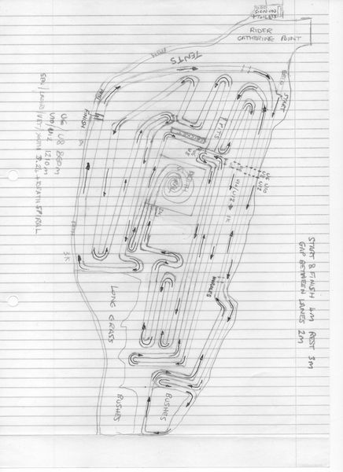
10:30 | load the kit into the van
12:00 | Unload
12:30 | Course mark up
Sun 04/12
07:30 Car park opens
07:40 Briefing | Attend briefing
07:59 | [Sunrise]
Sun 04/12 07:50 – 09:00 | Build course
09:00 – 10:00 | Sign on
 | Further course building.
 | Marshalling
 | Car Park
10:00 – 11-00 | Sign on
 | Marshalling
 | Car Park
11:00 – 12:00 | Sign on
 | Marshalling
 | Car Park
12:00 – 13:00 | Sign on
 | Marshalling
 | Car Park
13:00 – 14:00 | Sign on
 | Marshalling
 | Car Park
14:00 – 16:00 | Sign on
 | Marshalling
 | Car Park
15:55 | [Sunset]
16:00 – 17:00 | Course dismantle

Course Location
